SECURE MICROSERVICE DEPLOYMENT ON AWS USING TERRAFORM AND DOCKER

PROJECT PURPOSE: The purpose of this project is to automate the deployment of a containerized web application on AWS using terraform Infrastructure as Code (IaC). The project provisions a secure cloud infrastructure, deploys the application inside a Docker container on an EC2 instance and exposes it only through an application Load Balancer. This implementation demonstrates cloud infrastructure automation, secure networking and container deployment using AWS best practices.

PROJECT OBJECTIVE:
- Build a Docker image for a simple Nginx-based web application serving a static HTML page.
- Push the Docker image to a Docker registry (Docker Hub).
- Provision AWS infrastructure using Terraform.
- Create a custom VPC with public and private subnets.
- Configure Internet Gateway, NAT Gateway, Route Tables, and Security Groups.
- Create and upload an SSH Key Pair using Terraform.
- Launch an EC2 instance in a private subnet.
- Install Docker automatically using EC2 User Data.
- Pull the Docker image from Docker Hub and run it as a container.
- Configure an Application Load Balancer to securely expose the application.
- Restrict direct access to the EC2 instance and allow SSH only from a trusted IP address.
- Organize the Terraform project using best practices such as variables, helper scripts, and modular code where appropriate.

PROJECT OUTCOME:
Upon successful completion of the project:
- A fully automated AWS infrastructure is provisioned using Terraform.
- A Dockerized Nginx web application is deployed on an EC2 instance.
- The Docker image is stored in Docker Hub and automatically pulled during deployment.
- The EC2 instance remains private and cannot be accessed directly over HTTP.
- The Application Load Balancer provides secure access to the application.
- SSH access is restricted to authorized IP addresses only.
- Infrastructure deployment becomes repeatable, scalable, and easy to manage through Infrastructure as Code.

PROJECT ARCHITECTURE:

Internet
│
Application Load Balancer
│
┌───────────────┴───────────────┐
│ │
Public Subnet (AZ-1) Public Subnet (AZ-2)
│ │
└───────────────┬───────────────┘
│
Target Group
│
EC2 Instance (Private Subnet)
│
Docker Container (Nginx)
│
Static HTML Web Application

Private Subnet
│
NAT Gateway
│
Internet Gateway
│
Docker Hub (Pull Image)

Goal of the Exercise
The goal of this exercise is to test your understanding of a Cloud Compute deployment with Terraform.
You are tasked with creating a codebase for a microservice deployment on a cloud environment, using Terraform. Since our focus is not the application itself, the service will be a simple web server that returns a static page.
Requirements
Service Details

The service will be a simple web server that returns a static page.

You can useapache2ornginxto serve a simple HTML file.

The service should becontainerizedand stored in aDocker registry.

The service should be deployed on asingle VM instanceas a docker container.

The image should be pulled from the registry specified earlier.

The service shouldnotbe accessible from the internet but only through aLoad Balancer, except for SSH access from specific IP addresses.

Deliverables
You are to provide the following as part of your solution:

Dockerfileto build the image.

Terraform codebaseto deploy the following:

Docker registry

VPC and all required networking resources

EC2 instance

Load Balancer

Notes

Since a CI/CD pipeline is not part of this exercise, we will work around that with the help of Terraform.

To push the image to the Docker registry,build the image locallybefore running the Terraform code.

Once the image registry is created, use Terraform topush the local imageto the registry.

Similarly, use Terraform topull the imagefrom the registry and run it on the VM instance once it is created.

For SSH access:

Use a locally created key.

Add it to the cloud provider key storage.

Attach it to the instance.

UseTerraform best practicesfor file structure and code organization.

Use variables, locals, modules, etc. when appropriate.

Include alltfvars, scripts, and other helper files used to deploy the application.

You may use any cloud provider of your choosing, althoughAWS is preferred.

Use afree tier accountor atrial accountto deploy the resources.

IMPLEMENTATION STEPS:

Step 1: Create the Application
- Create a simple index.html page.
- Create a Dockerfile using the Nginx base image.
- Build the Docker image locally.

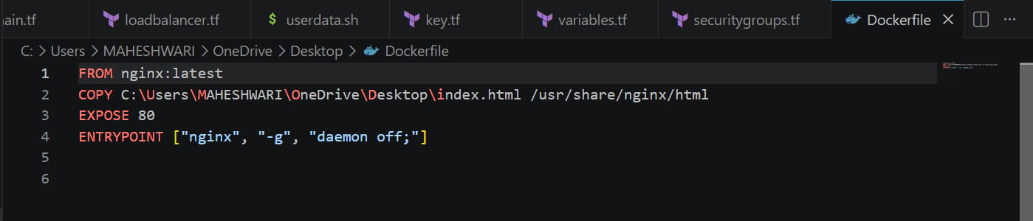

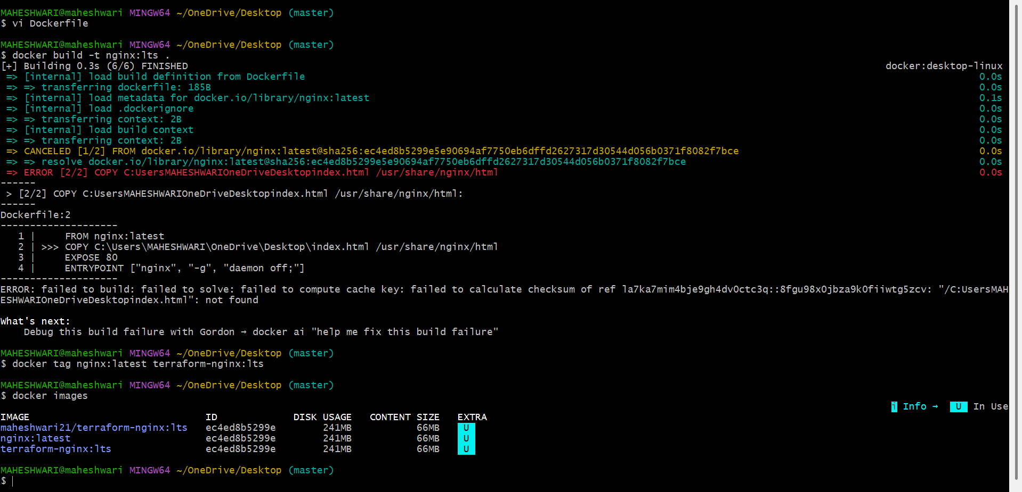

Step 2: Push the Docker Image
- Log in to Docker Hub.
- Tag the image.
- Push the image to Docker Hub.

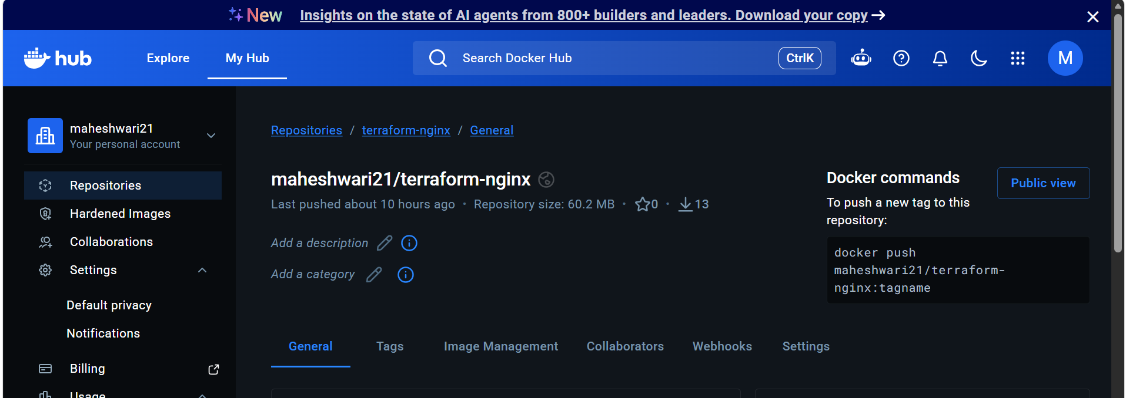

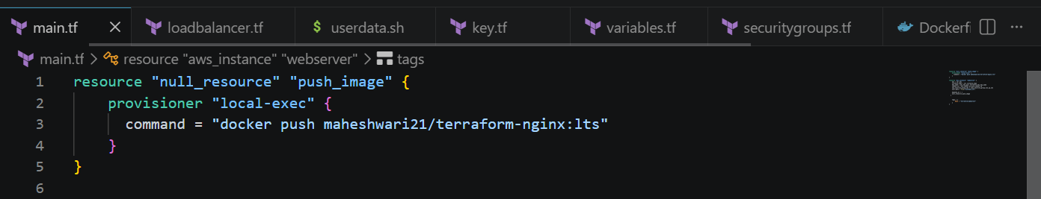

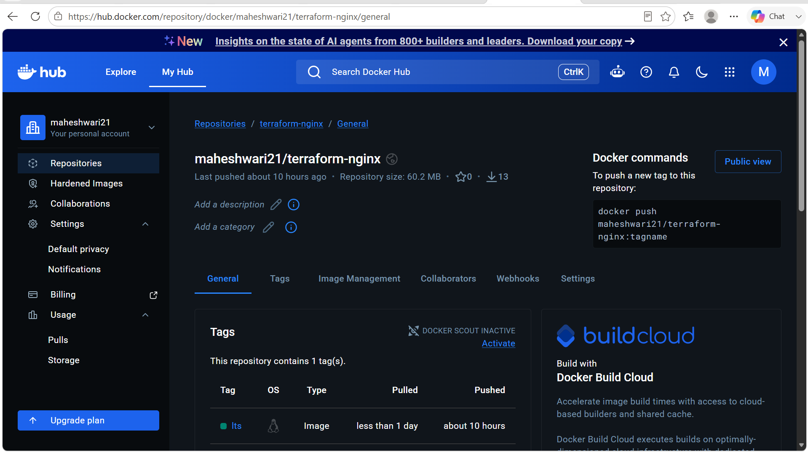

Step 3: Organize the Terraform Project
Create the project structure.

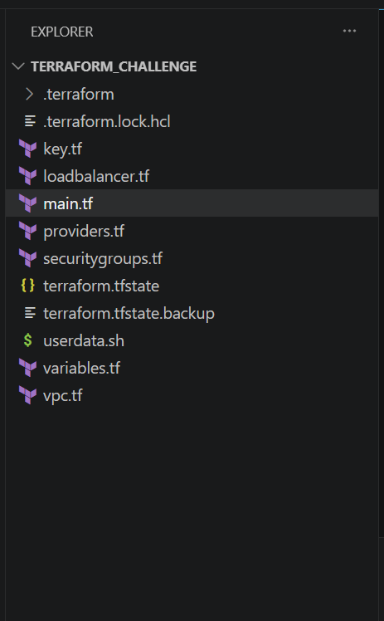

Step 4: Configure the AWS Provider
- Configure the AWS provider.
- Specify the AWS region.
- Initialize Terraform.

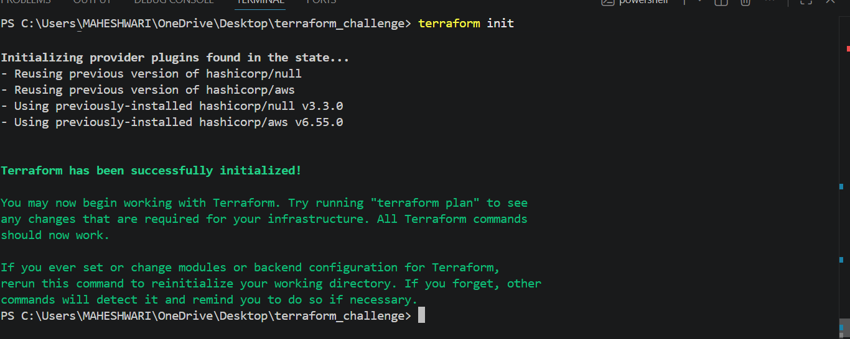

Step 5: Create Networking Resources
Provision:
- VPC
- Internet Gateway
- Public Subnets
- Private Subnet
- Elastic IP
- NAT Gateway
- Public Route Table
- Private Route Table
- Route Table Associations

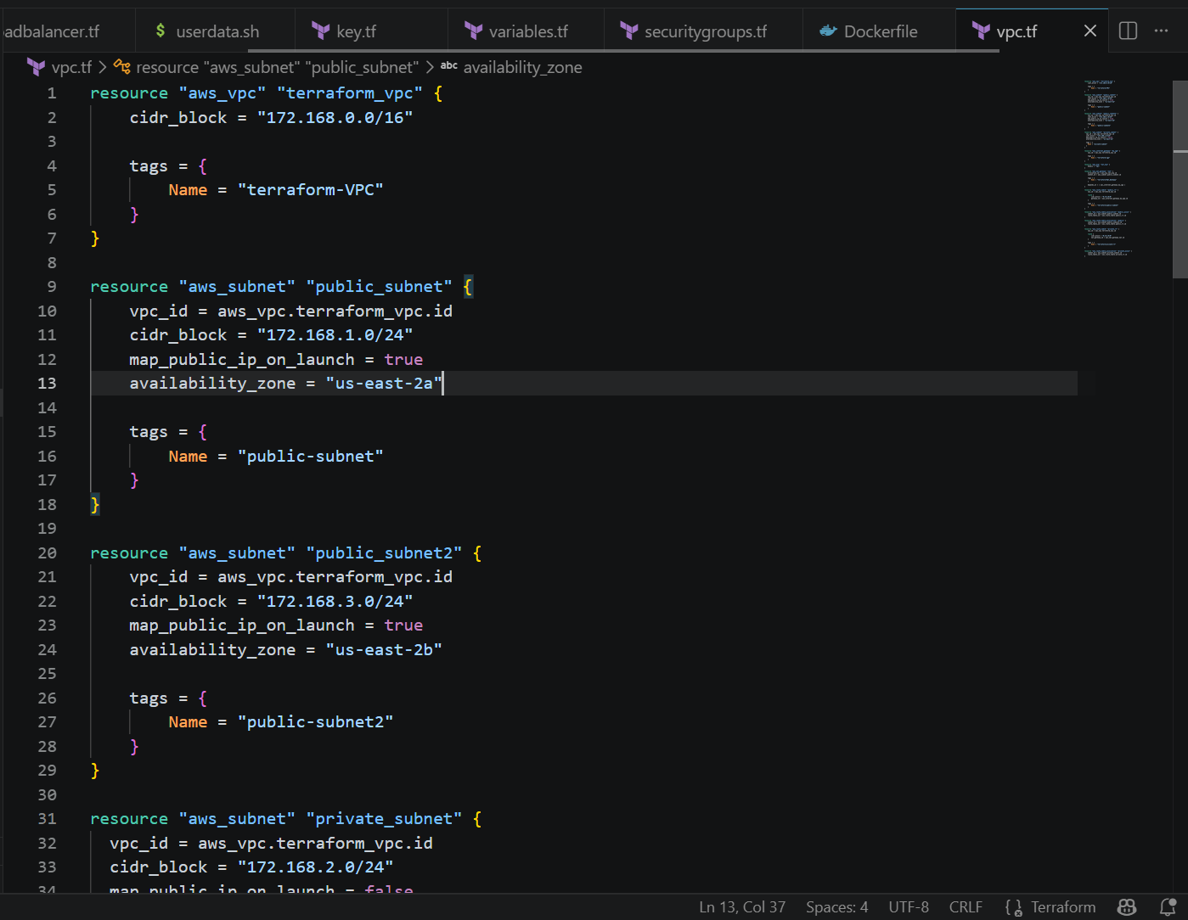

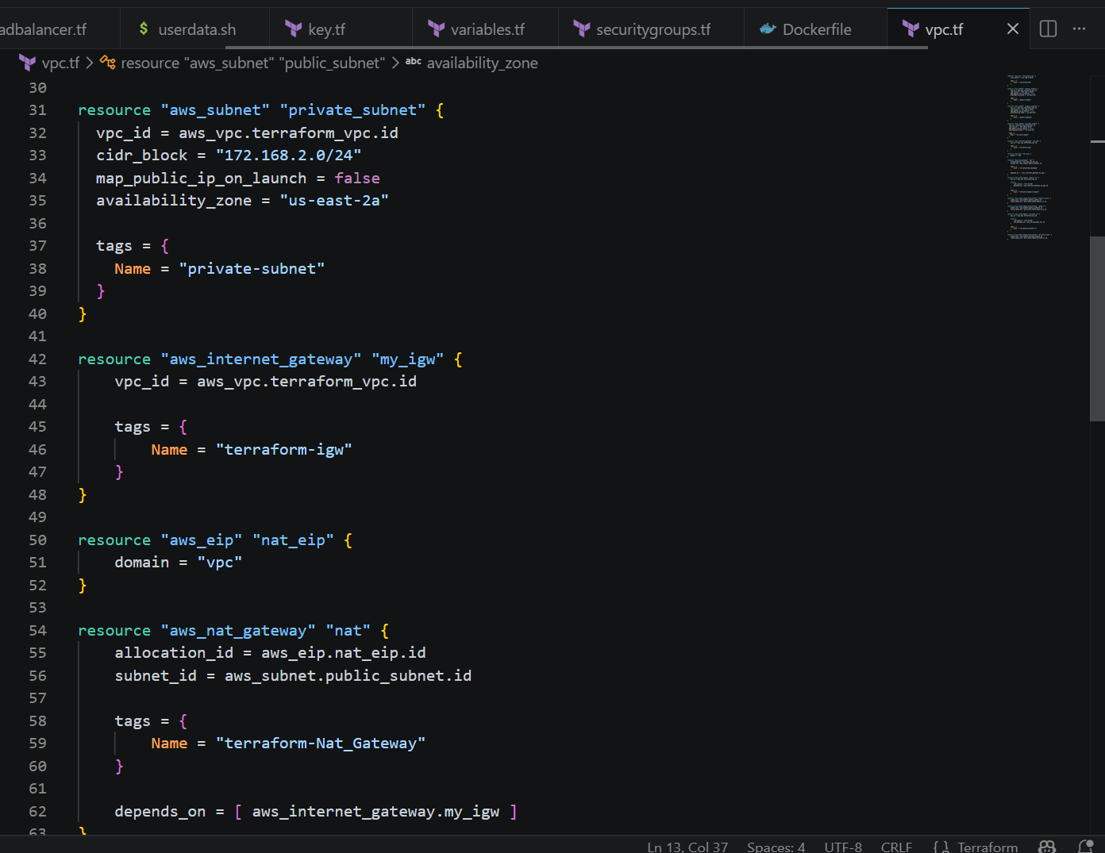

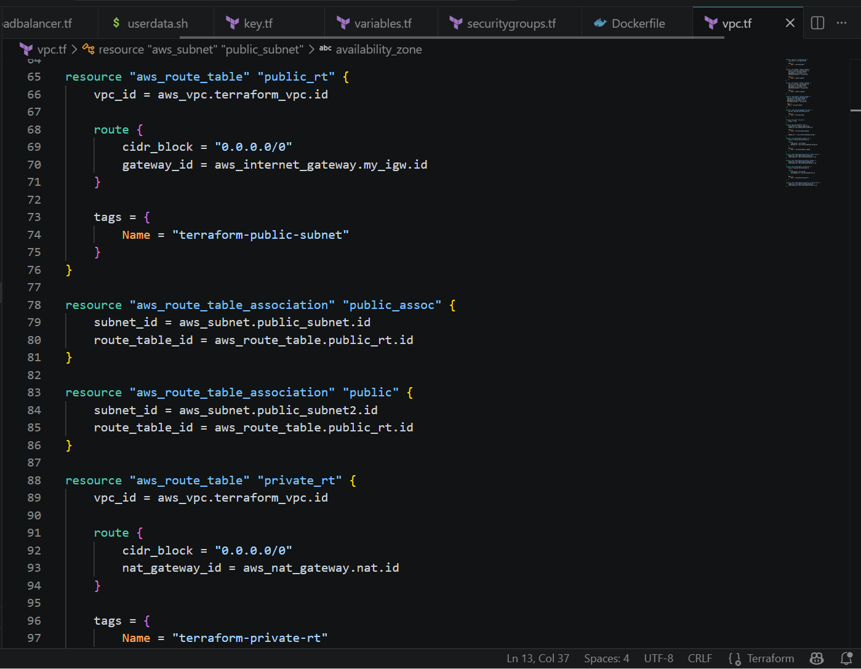

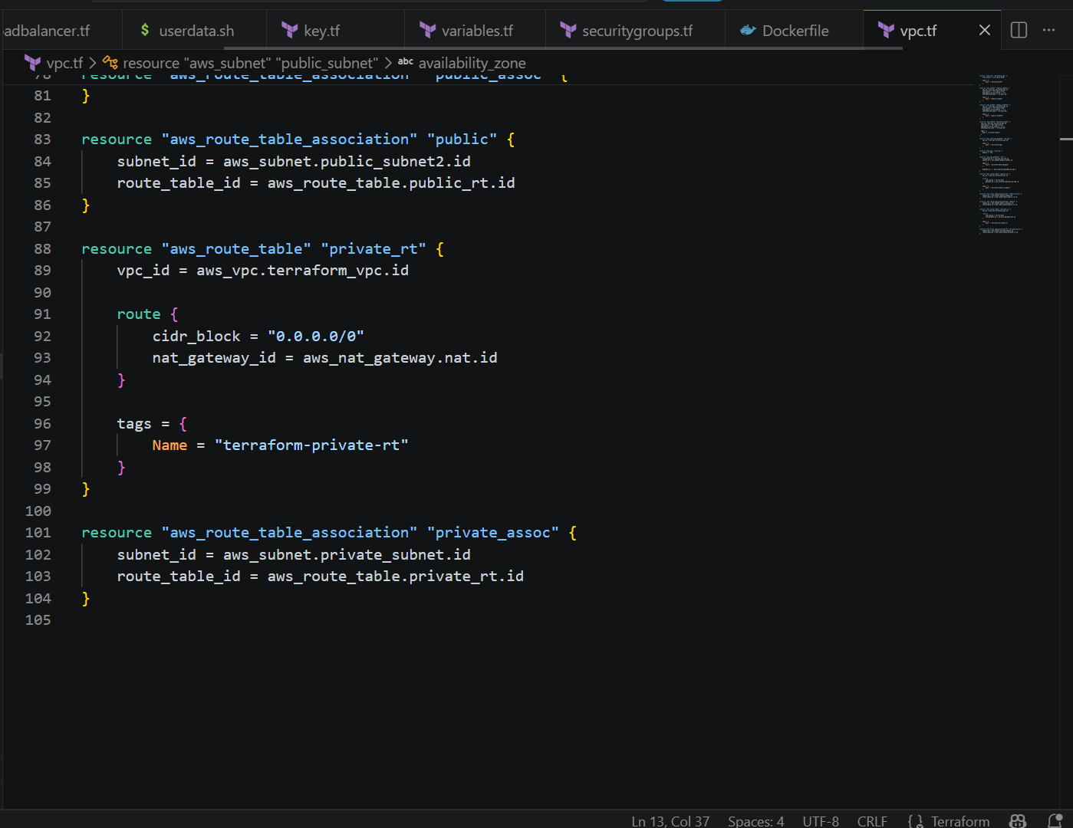

OUTCOME OF vpc.tf IN THE AWS:

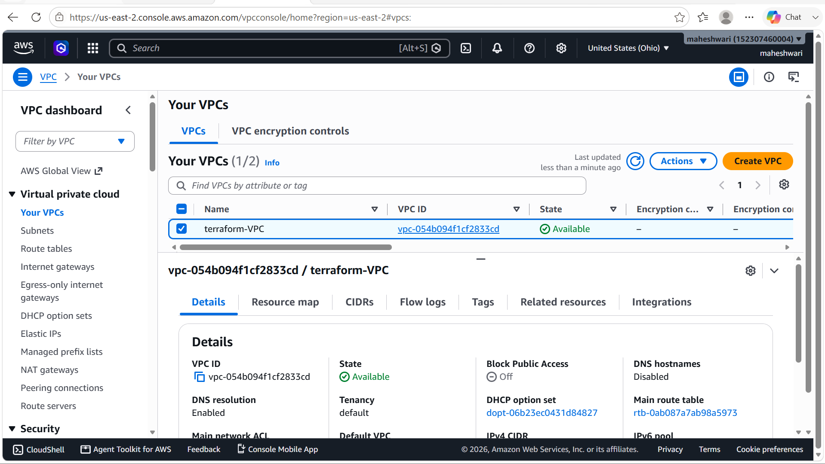

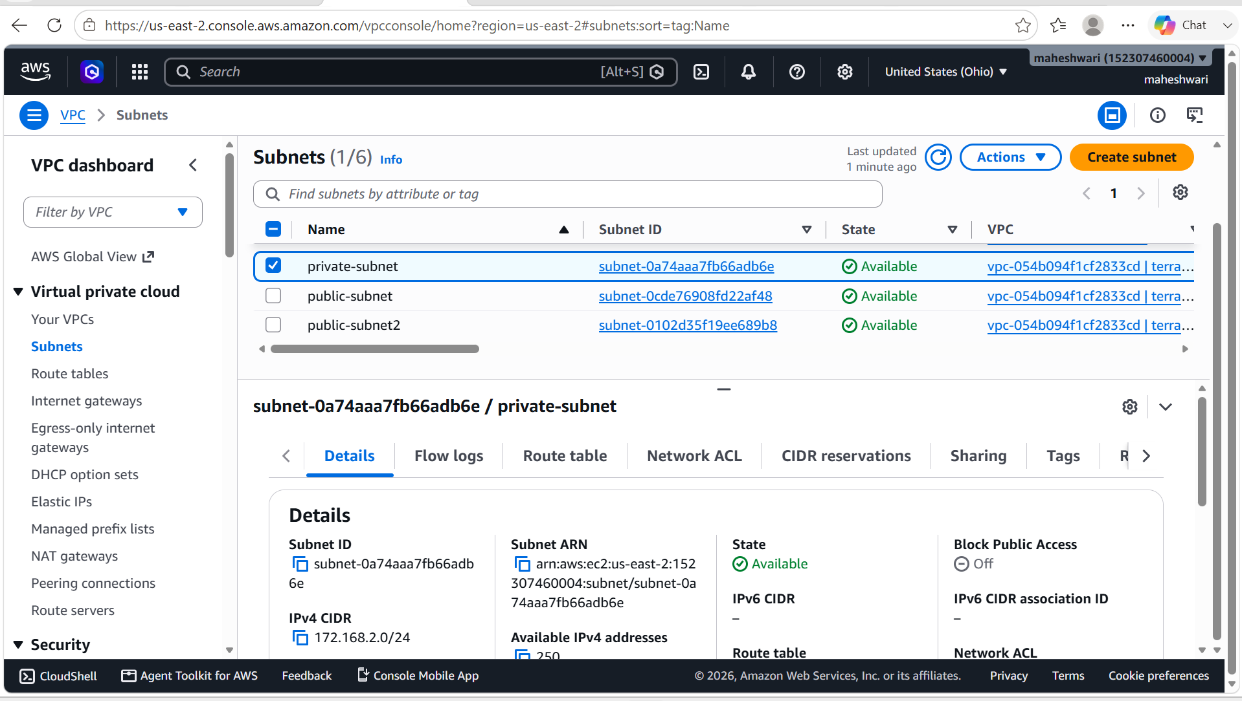

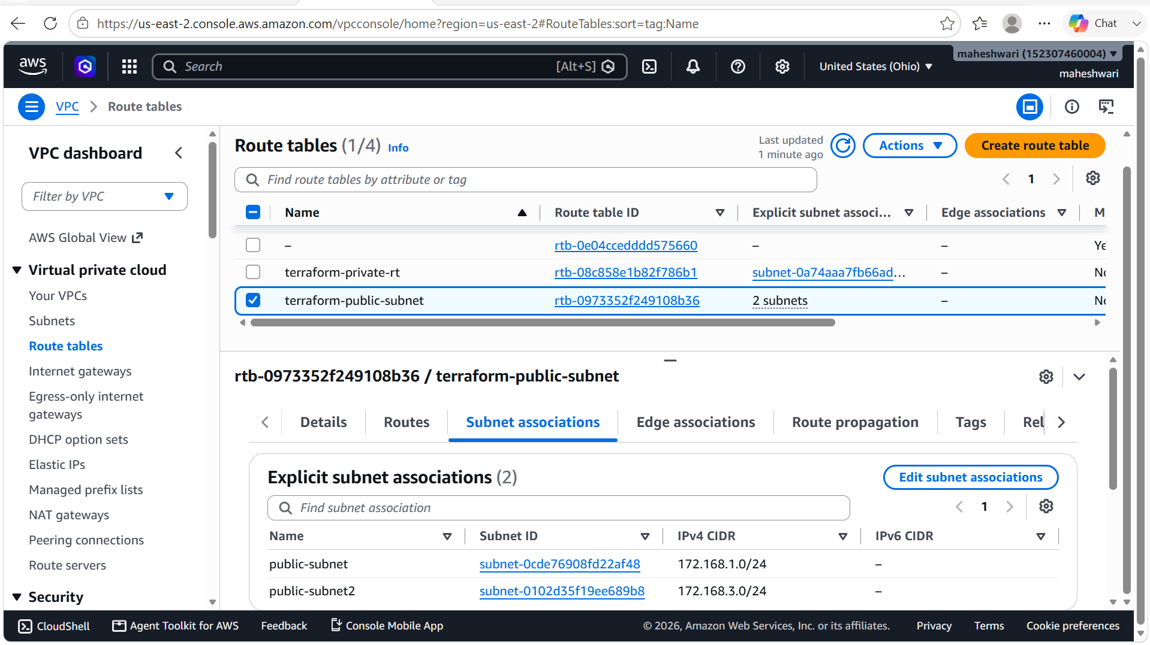

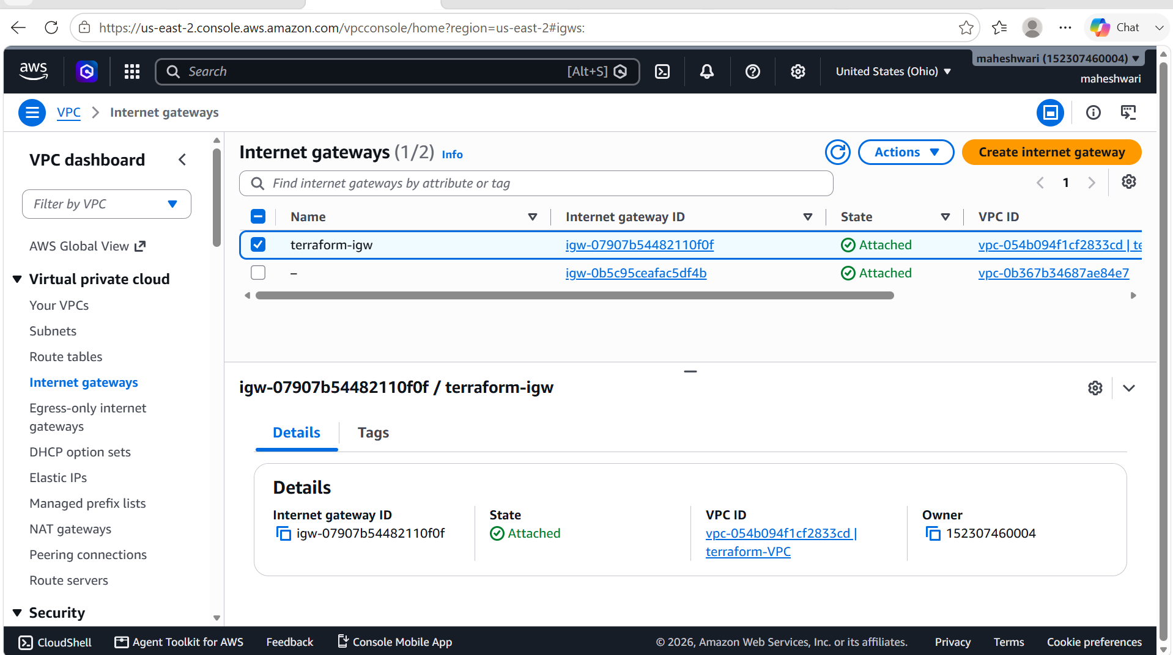

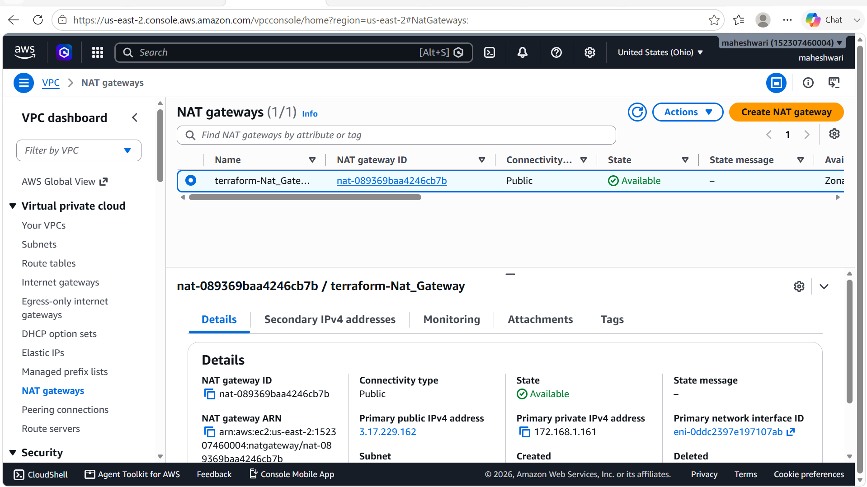

Step 6: Configure Security Groups
Create:
ALB Security Group
Allow:
- HTTP (80) from the Internet
EC2 Security Group
Allow:
- HTTP (80) only from the ALB Security Group
- SSH (22) only from the authorized public IP address

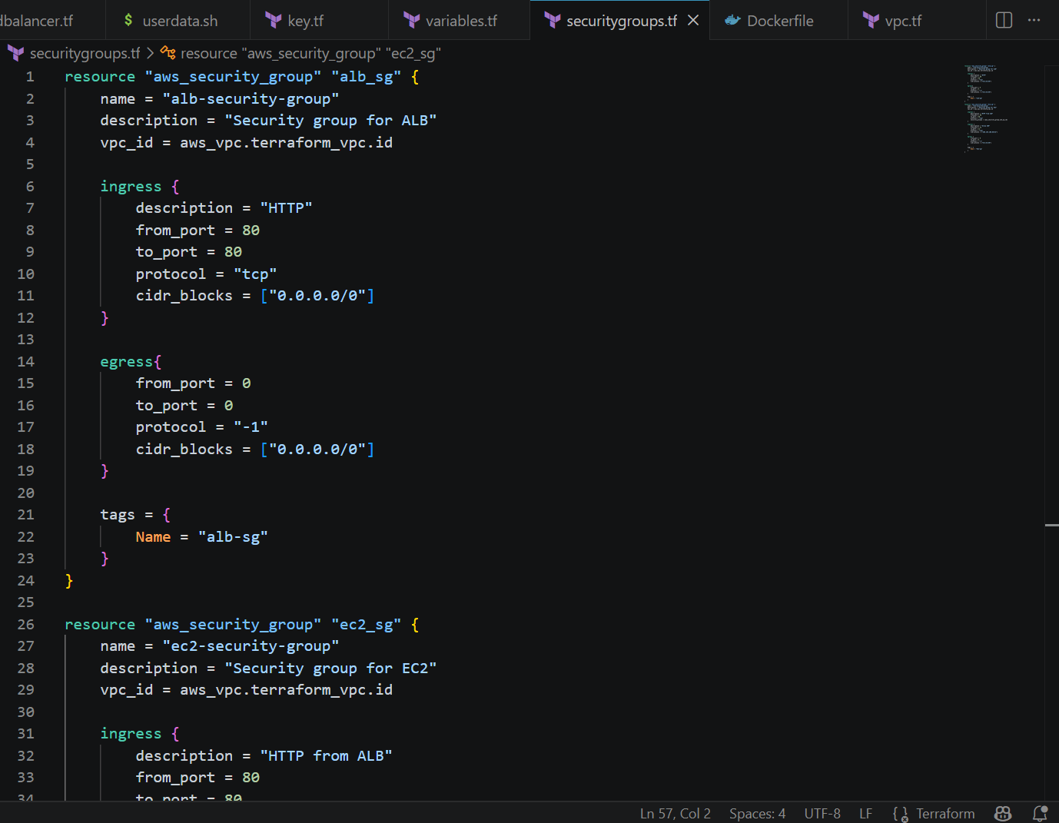

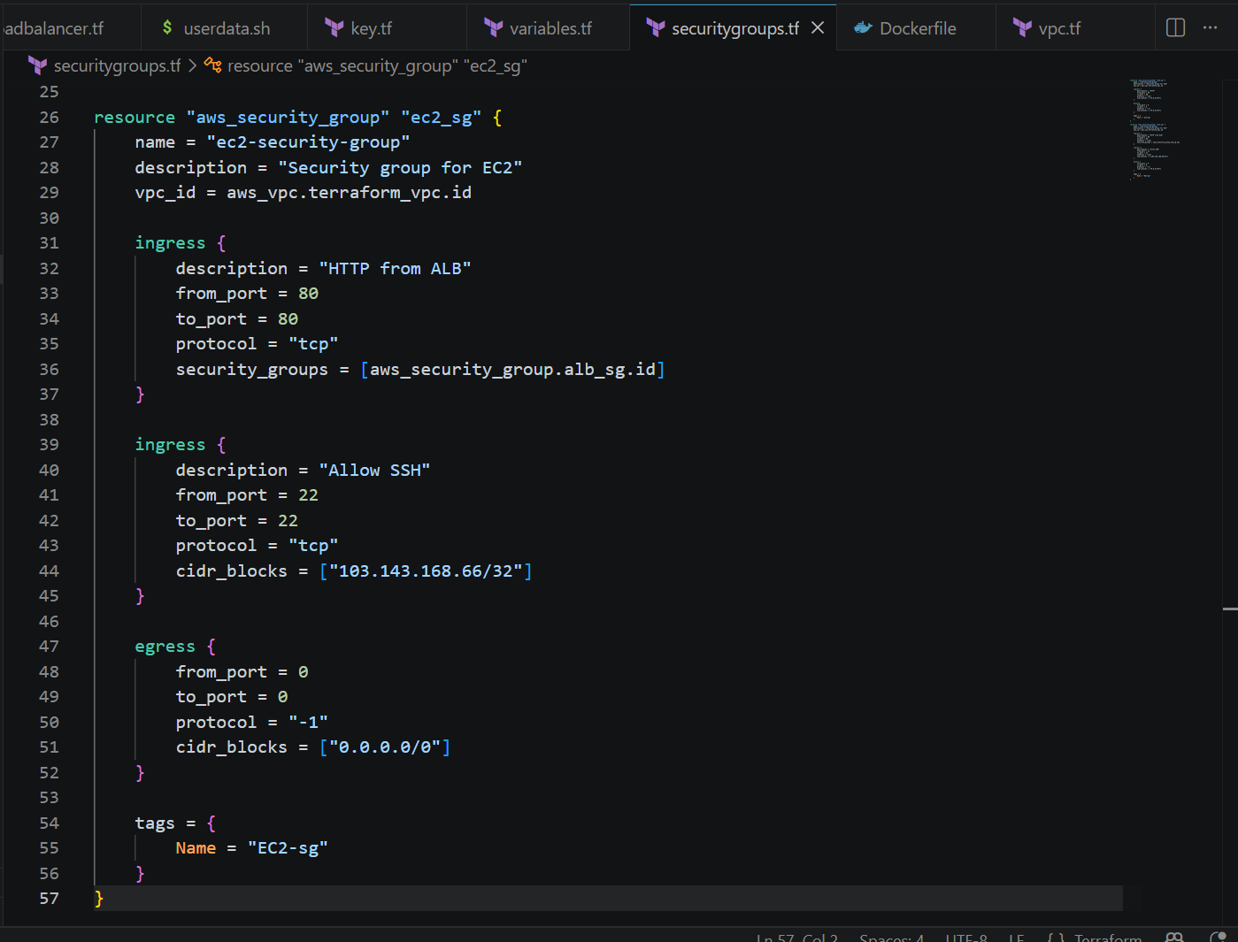

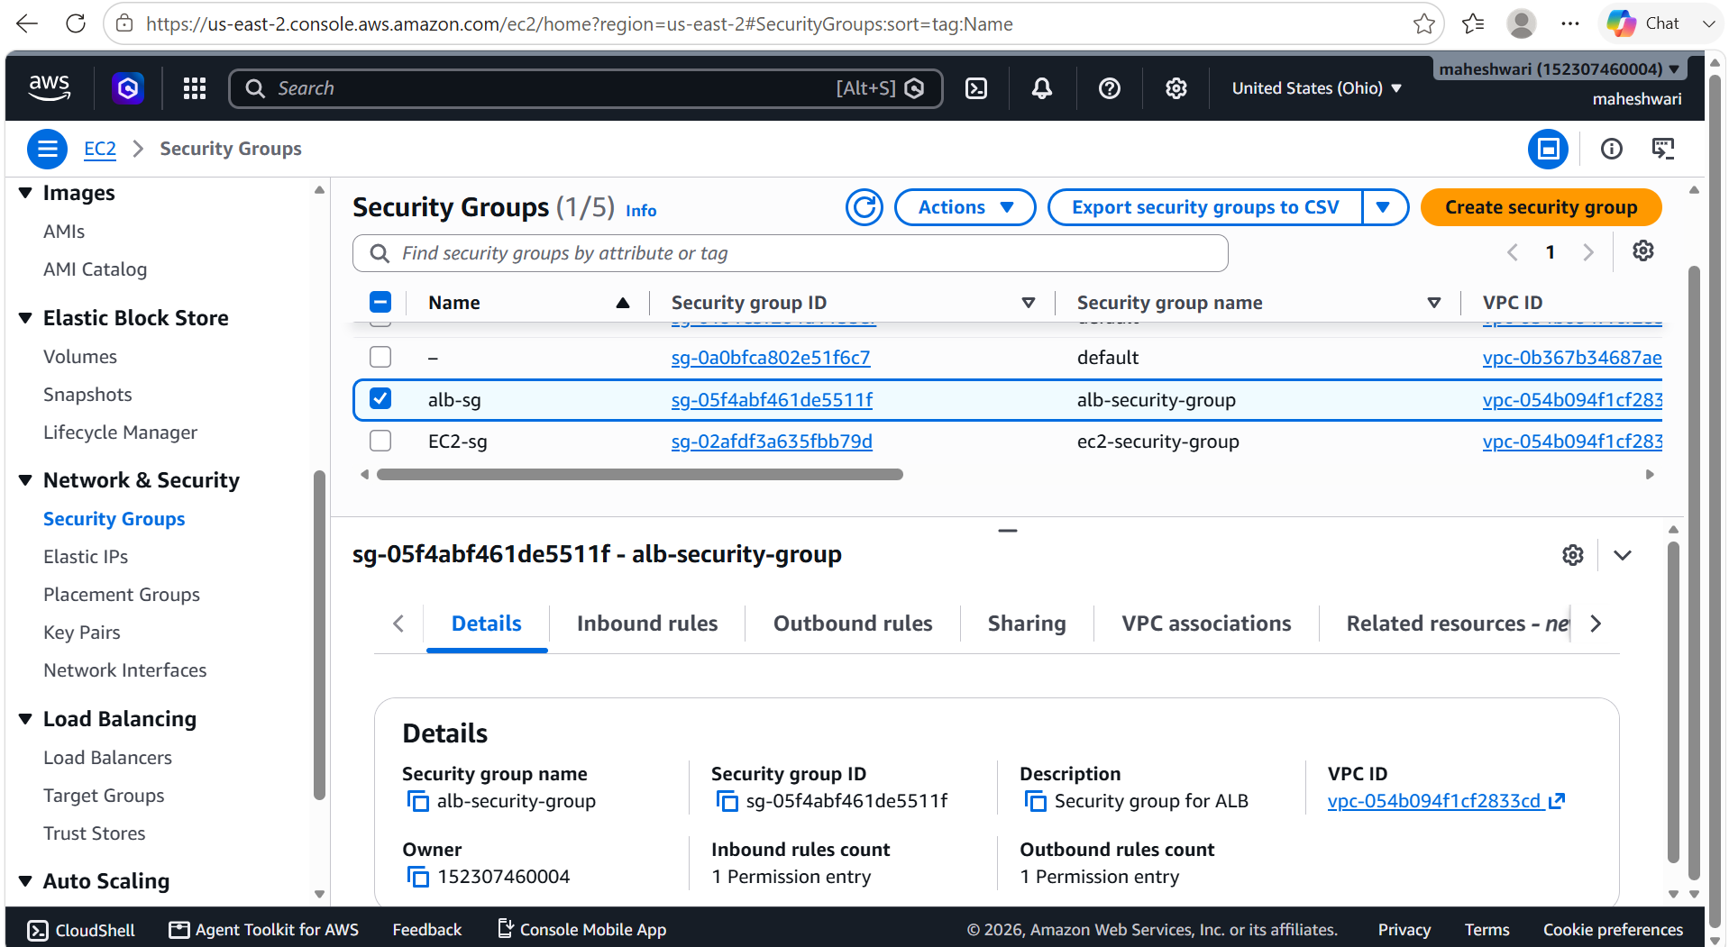

Step 7: Create SSH Key Pair
- Generate an SSH key locally.
- Upload the public key to AWS using Terraform.
- Attach the key pair to the EC2 instance.

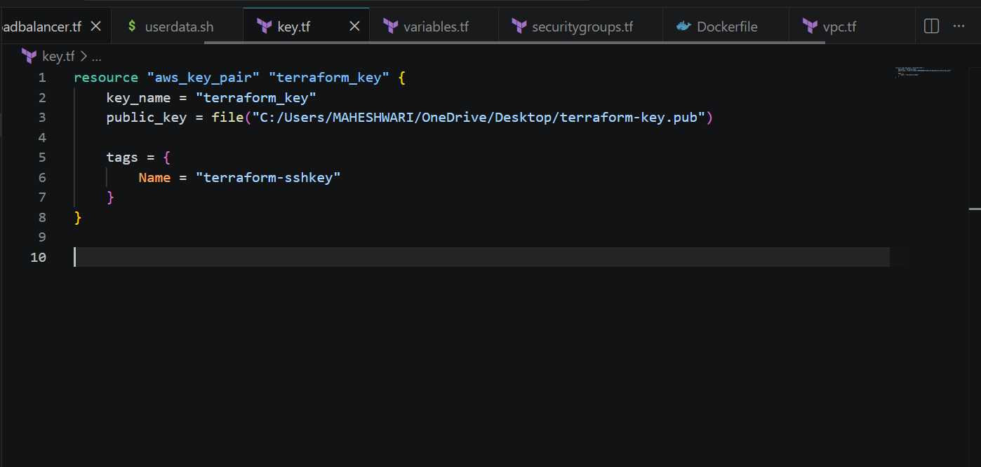

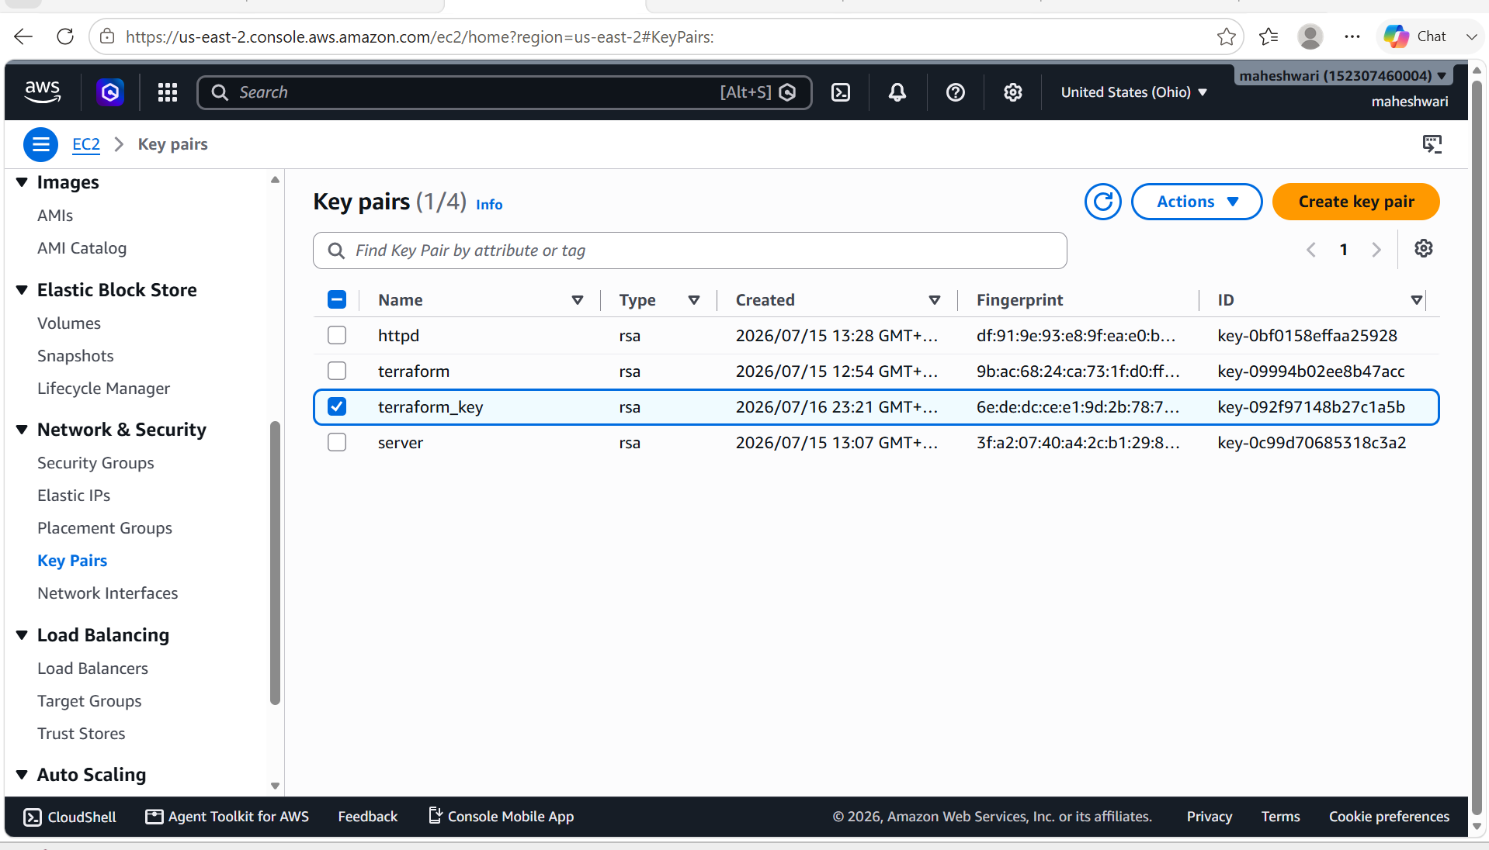

Step 8: Launch the EC2 Instance
Provision an EC2 instance in the private subnet with:
- Amazon Linux
- Docker installation
- User Data script
- Docker image pull
- Docker container execution
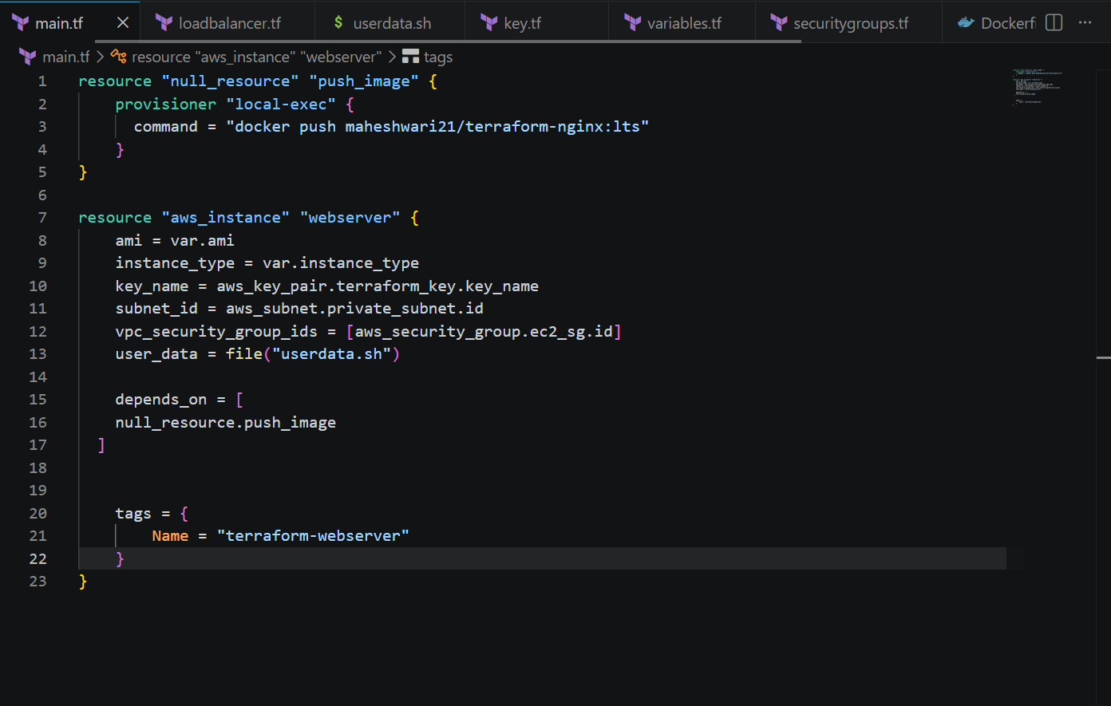

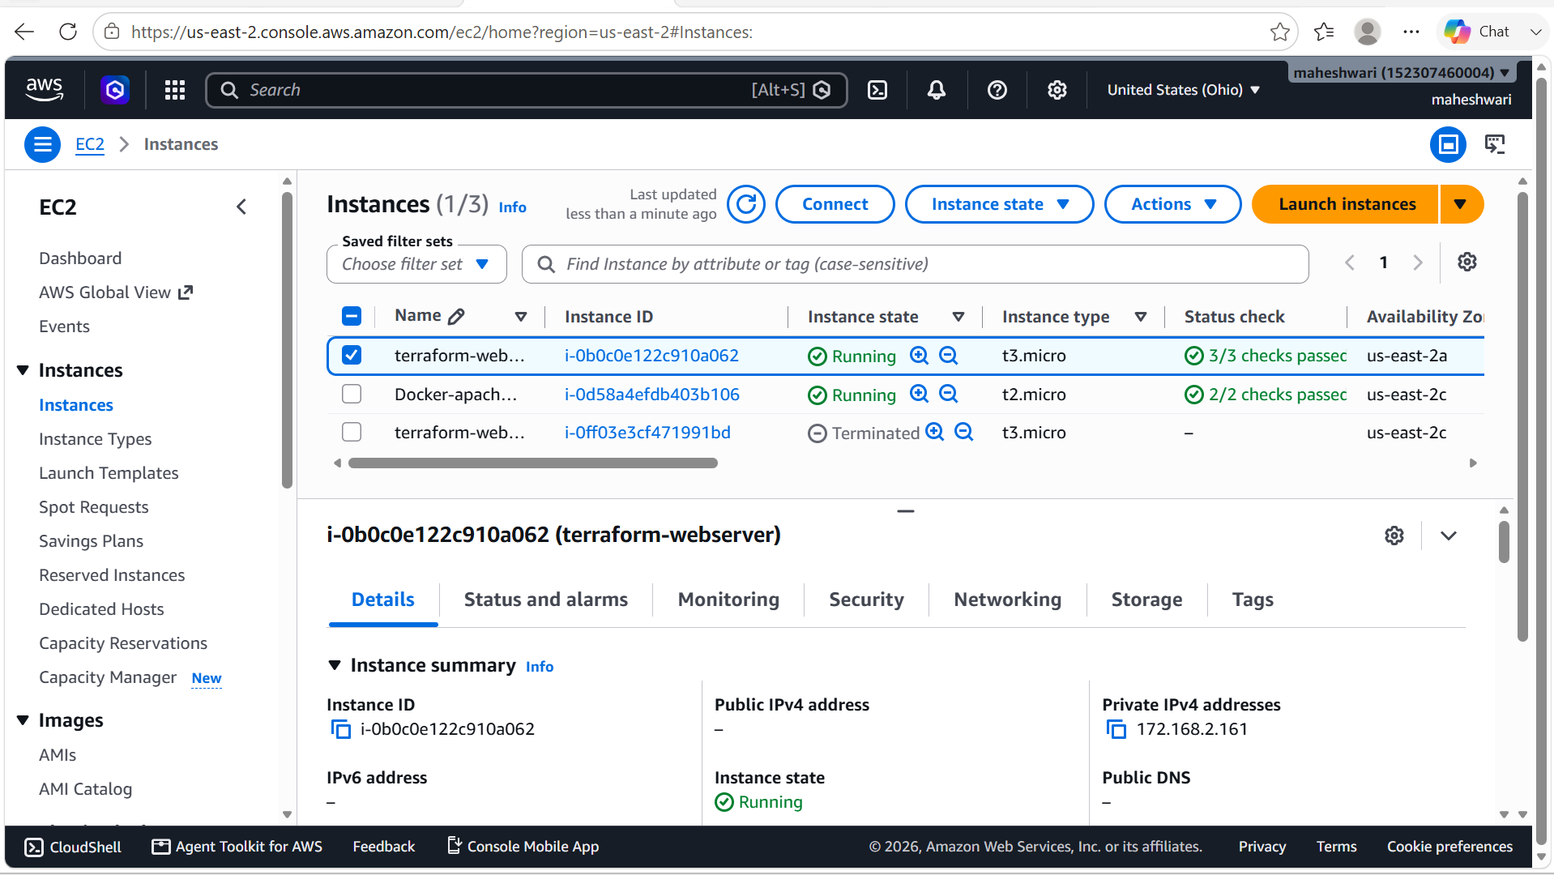

Step 9: Configure User Data
The User Data script automatically:
- Updates the operating system
- Installs Docker
- Starts and enables the Docker service
- Pulls the Docker image from Docker Hub
- Runs the container on port 80

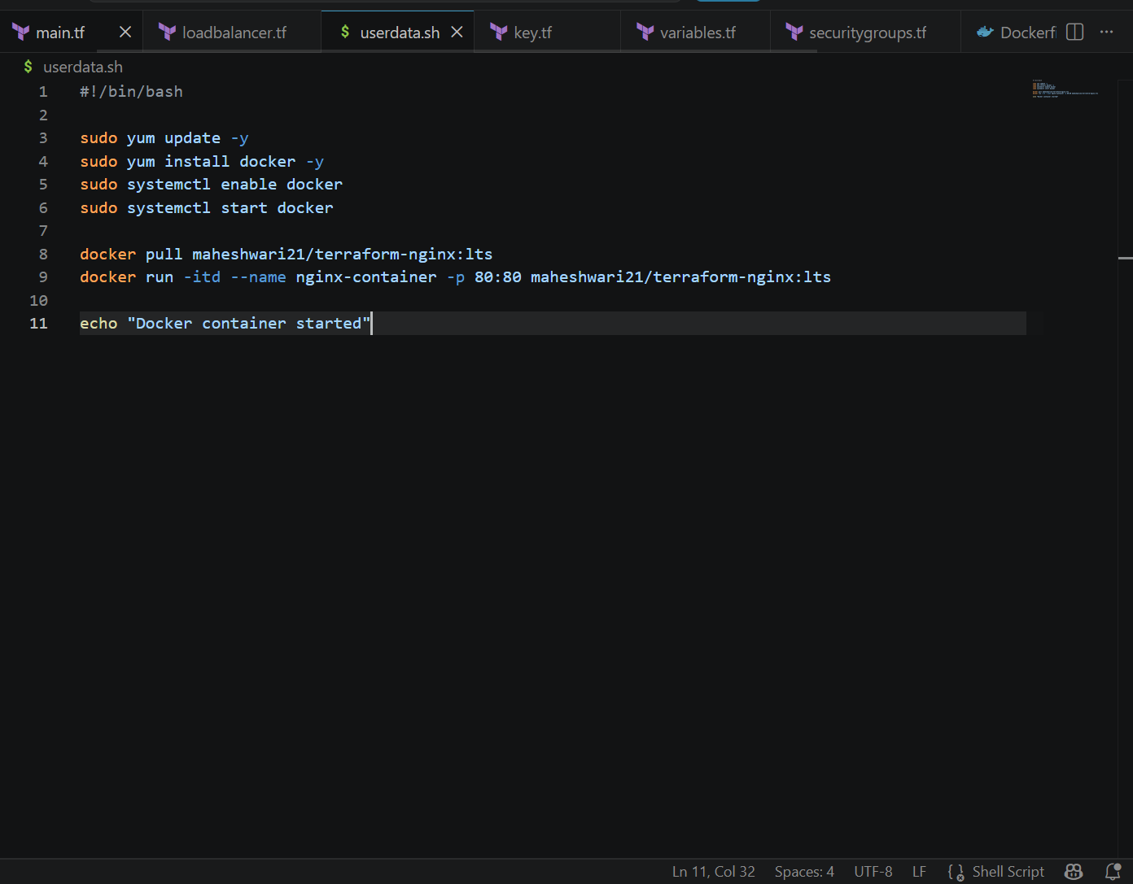

Step 10: Create the Application Load Balancer
Provision:
- Application Load Balancer
- Target Group
- Listener
- Health Checks
The ALB forwards HTTP requests to the EC2 instance.

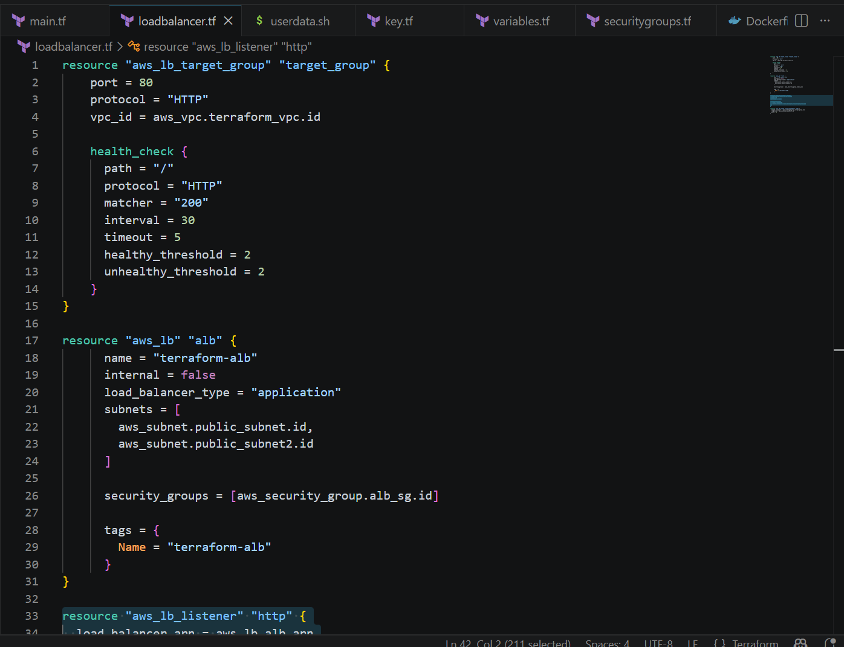

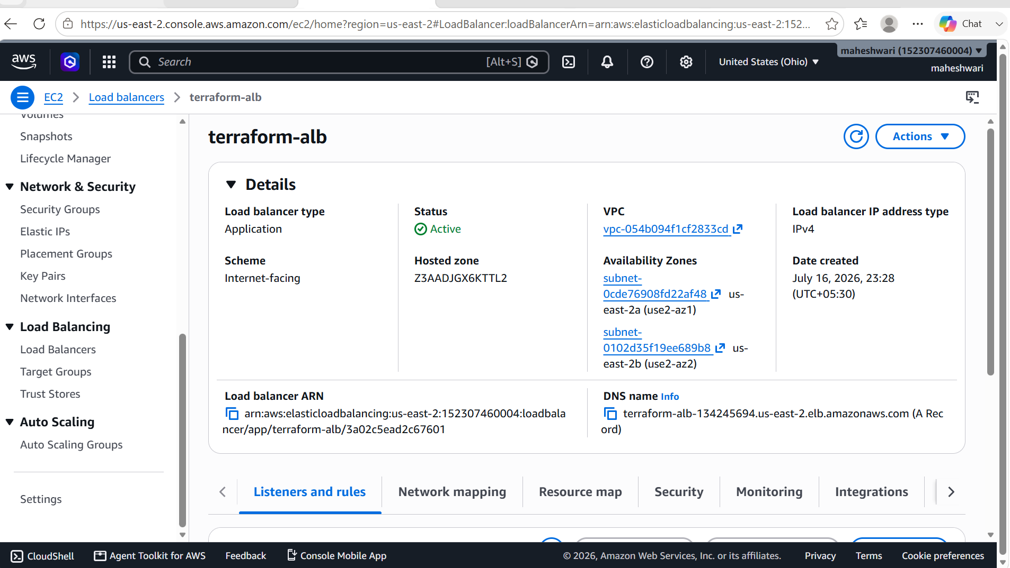

Step 11: Register EC2 with the Target Group
Attach the EC2 instance to the Target Group and verify that the health status becomes Healthy.

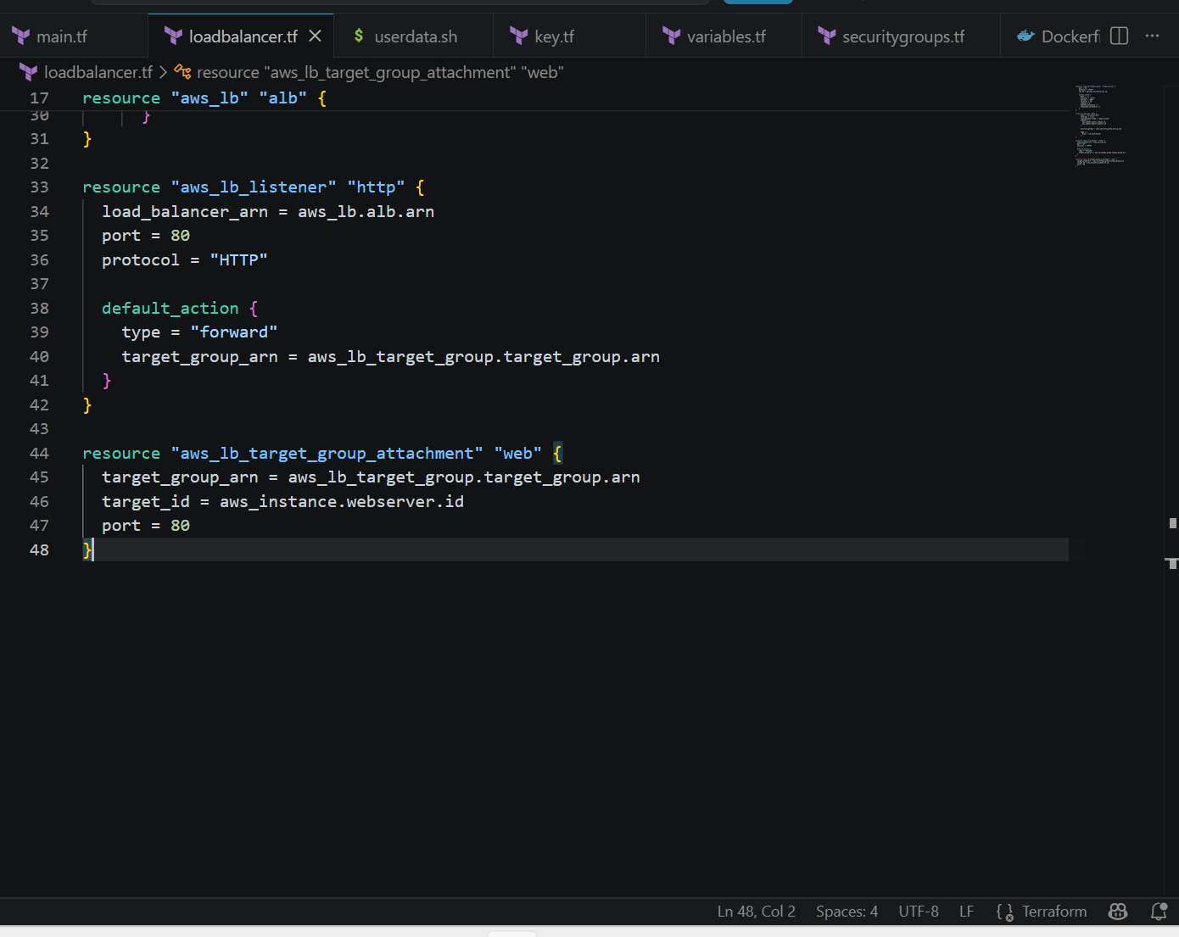

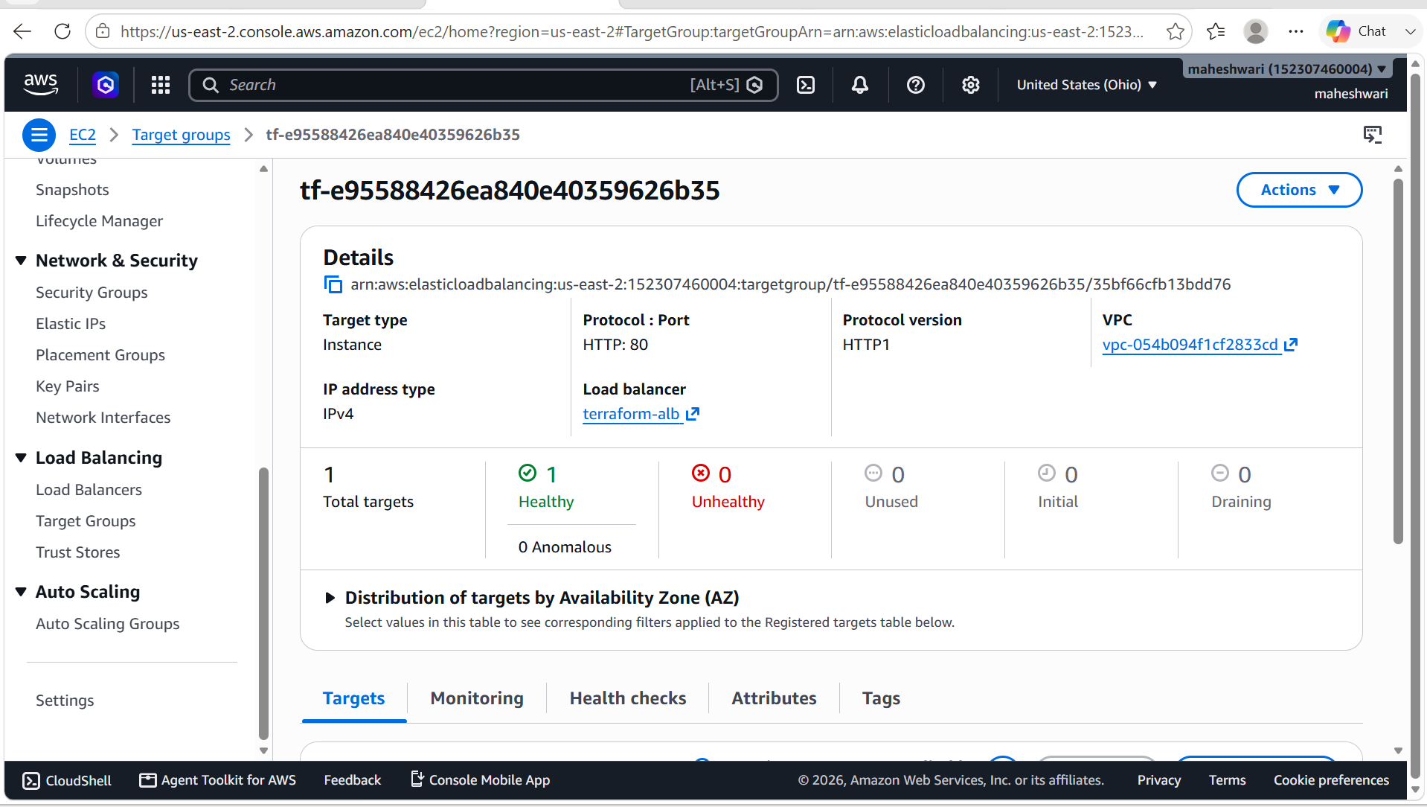

Step 12: Deploy the Infrastructure
Run:
terraform plan

terraform apply
Terraform provisions all AWS resources automatically.

Step 13: Verify the Deployment
- Confirm that the Docker container is running.
- Verify the Target Group health status.
- Access the application using the ALB DNS name over HTTP.
- Ensure direct HTTP access to the EC2 instance is blocked.
- Verify that SSH access is allowed only from the configured IP address.

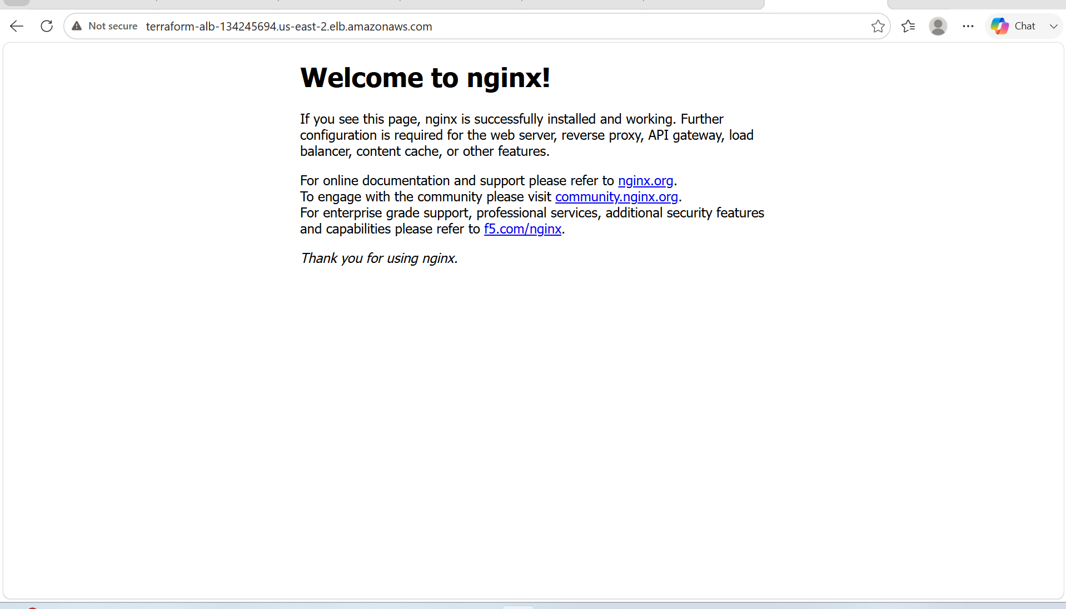

Technologies Used
- Terraform
- AWS EC2
- Amazon VPC
- Application Load Balancer (ALB)
- Security Groups
- Internet Gateway
- NAT Gateway
- Docker
- Docker Hub
- Nginx
- Amazon Linux
- Git

